- 6 Dec 2015
- Sunday Times
- BOBBY JORDAN jordanb@sundaytimes.co.za

Cape village left high and dry by war over water

Farmers upstream of Bainskloof Village are diverting most of the river to their land
❛ I’m the third generation to farm here and it’s all been built on this water. It was allocated to us’
GABRIELLA Rivera knew something strange was happening to the river running past her house in Bainskloof Village; it had slowed to a trickle.
What she didn’t know was that a group of farmers diverting water to their fields along a stone canal built 3km upstream have been taking a whopping 99% of the river, leaving the mountainside town literally high and almost dry.
Now the standoff over the Witte River, above Wellington, has degenerated into a cat-andmouse game in which farmers try to keep their canal full, and government officials try to open sluicegates to let water back into the river.
Municipal pipes linking the river to the Bainskloof reservoir have had to be moved to a deeper pool because the supply of household water has been threatened.
Now the Green Scorpions have been directed to intervene following an inspection of the area.
CapeNature officials also confirmed they would hold an emergency meeting to discuss new scientific data obtained on Monday showing the extent of the problem.
It shows that farmers are extracting 126 litres a second from the river through their canal, and only a little more than a litre a second is left flowing down the river bed — way below the level needed to preserve the river ecology.
The river is coming to a standstill while most of the flow disappears over the hill into the farmlands below.
The standoff has been aggravated by below-average rainfall, which has reduced the amount of available water in the Boland Mountain Complex, which is part of the Cape Floral Region Protected Areas World Heritage Site.
The farmers’ canal dates from around 1860, when permission was granted to transfer a portion of the river water to irrigate 11 farms in the Bovlei farming district.
The system is managed by the Krommerivier Irrigation Board, whose members include former Western Cape farmer of the year Jannie Bosman snr, of JC Bosman Boerdery.

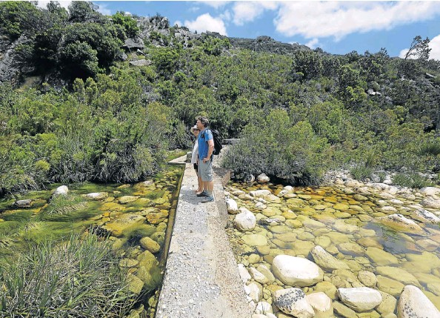
PARTING OF THE WATERS: Gabriella Rivera and her husband, Stephen, at the weir where ‘Gawie se Water’ is led off the Witte River
He says the system has been working well for more than a century, since the reign of Queen Victoria when the Cape was a British colony.
“I’m the third generation to farm here and it’s all been built on this water,” Bosman said.
“Everything is planned around the water. It was allocated to us.
“Why would you plant if you don’t have water?”
He said the livelihood of thousands was at stake if the irrigation scheme was revoked.
However, conservation officials and other river stakeholders — including research scientists, downstream residents, and fishermen — say the farmers are not only mistaken, they are acting unlawfully.
They say the farmers should build a dam to store excess winter run-off, which they could use during the dry summer months rather than exhausting the river’s supply.
Bainskloof homeowner Gillian Dodington, 74, said the river flanking Bainskloof Village was steadily disappearing. “We used to dive into the water in some pools. You dare not do it now,” she said, adding that the farmers appeared to be taking more water than in earlier years.
The Sunday Times visited the area this week and established that:
The water scheme, dubbed “Gawie se Water” in honour of Gawie Retief, who came up with the idea, has been contentious for years.
In the ’80s, farmers bulldozed a river bank to protect their canal.
CapeNature officials met farmers in 2009 to raise concerns about the river running dry in the dry summers.
A follow-up meeting was held last week and farmers agreed to open their sluicegates 5cm to allow water back into the river.
But when officials inspected the gates last Sunday, they had been opened only 1cm.
They have since been bolted shut, leaving only a single small hole in one gate.
A visit to the area this week confirmed that the river downstream from the canal is just a trickle, dotted with stagnant pools.
Dodington said she sympathised with farmers who sometimes had to struggle to make ends meet.
However, their rights could not be allowed to trump the life of a river. “Nobody has the right to take the whole river, regardless of what Queen Victoria had to say,” she said. Comment on this: write to tellus@sundaytimes.co.za or SMS us at 33971 www.sundaytimes.co.za

